**Instruction Document**

**of**

**ECMSData Annotator**

**Login & Registration Module**

This is a simple login and registration interface, nothing special

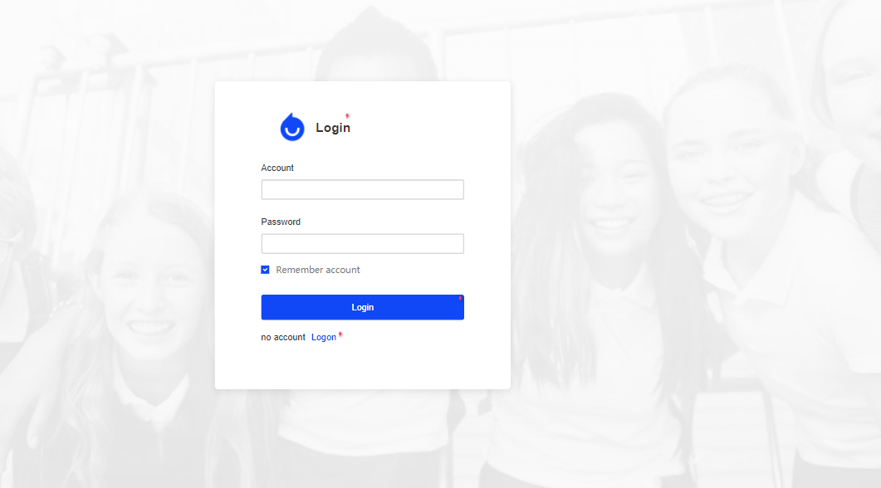

**Annotate function**

The user can select import or export dataset in this interface

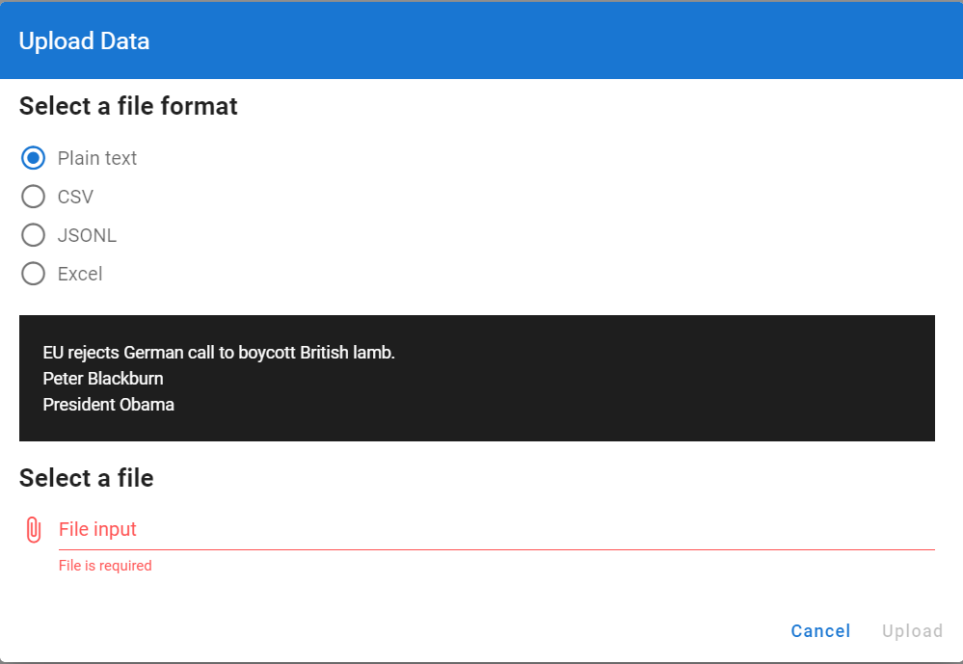Specific file import interface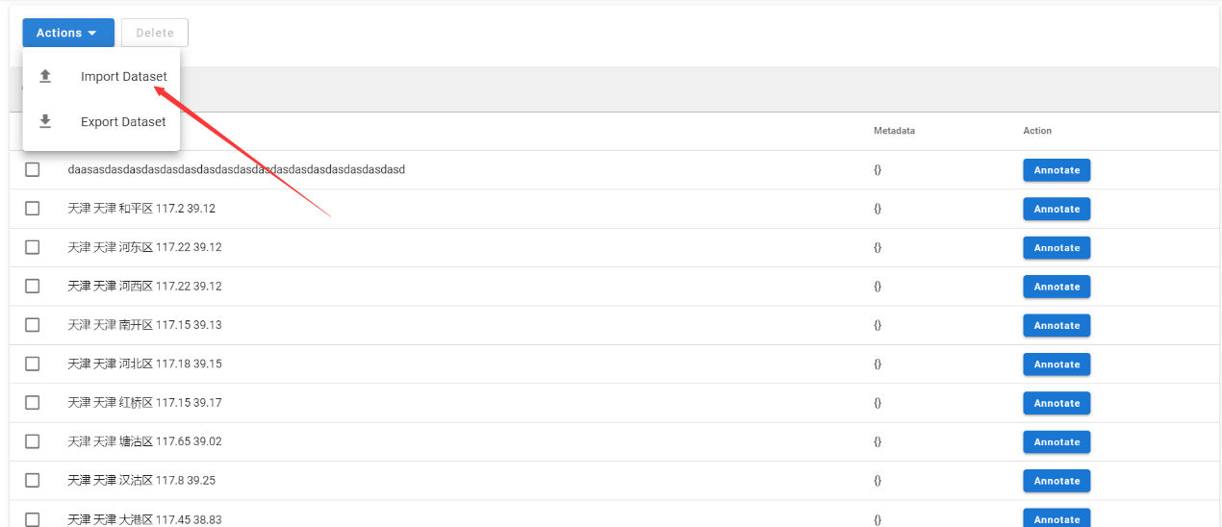

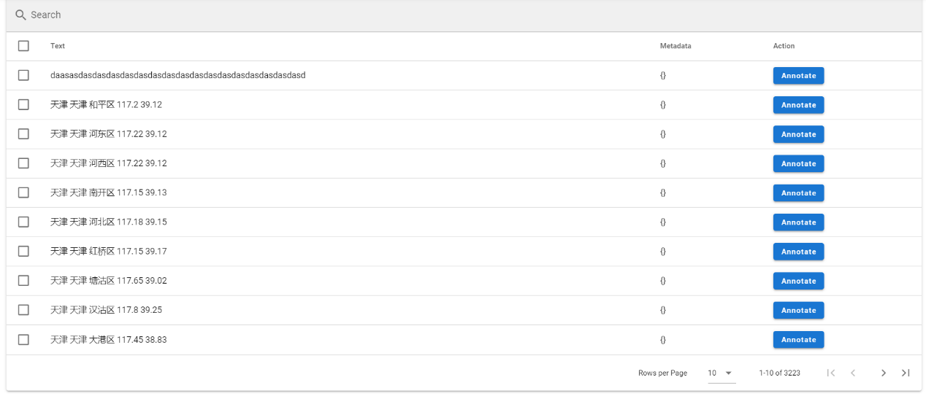Imported annotable files will be listed

Before the annotation, the user needs to establish the required label in advance.

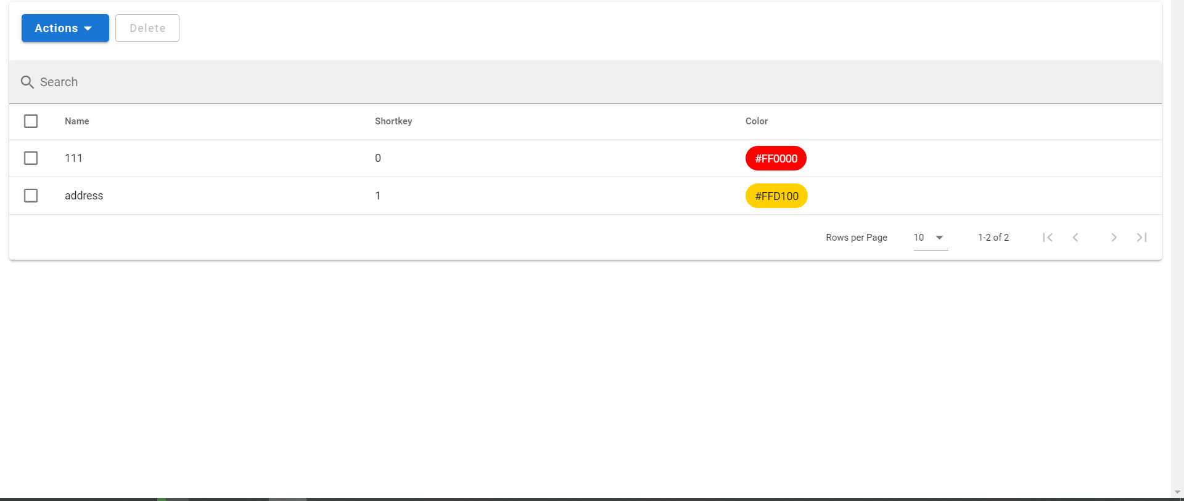

Then user can then select a label to annotate the DataSet that has been imported

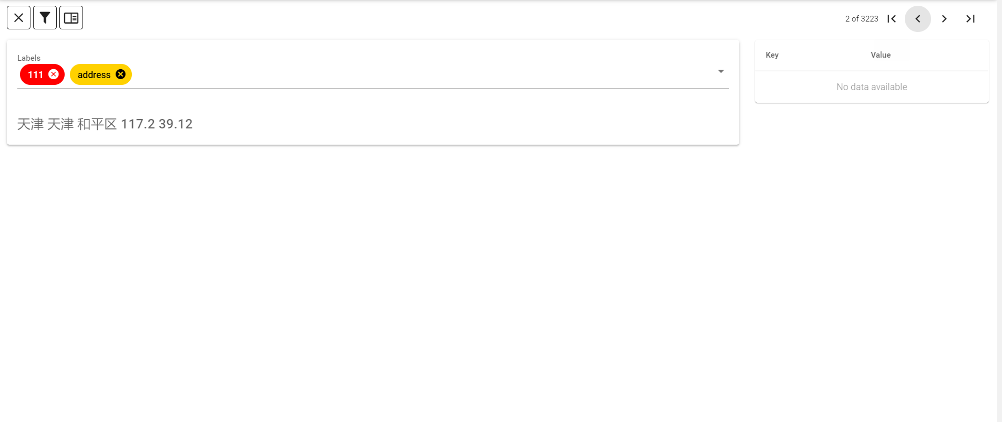

**New feature--Collaboration notation**

In addition to the basic annotation functionality, we also want to implement some new features that make our annotation tool unique. So we came up with the collaborative annotation feature.

This feature was inspired by office software such as Office and WPS. In these applications, we can share files with other people and edit them at the same time, and we want to do the same thing. For some large annotating work, the project manager can create a group and add other members to the group while annotating a large number of DataSets.

At the same time, we also set up the administrator, approval personnel and annotation personnel in the team to ensure the rationality and feasibility of this function.

We already have some ideas and prototypes for this new feature. However, it is undeniable that our ideas and conception of this new function are not comprehensive and perfect enough. We will try our best to develop and improve this function in the future work. We also hope that you can put forward some suggestions for our ideas.

**The main interface**

The user can see all the information clearly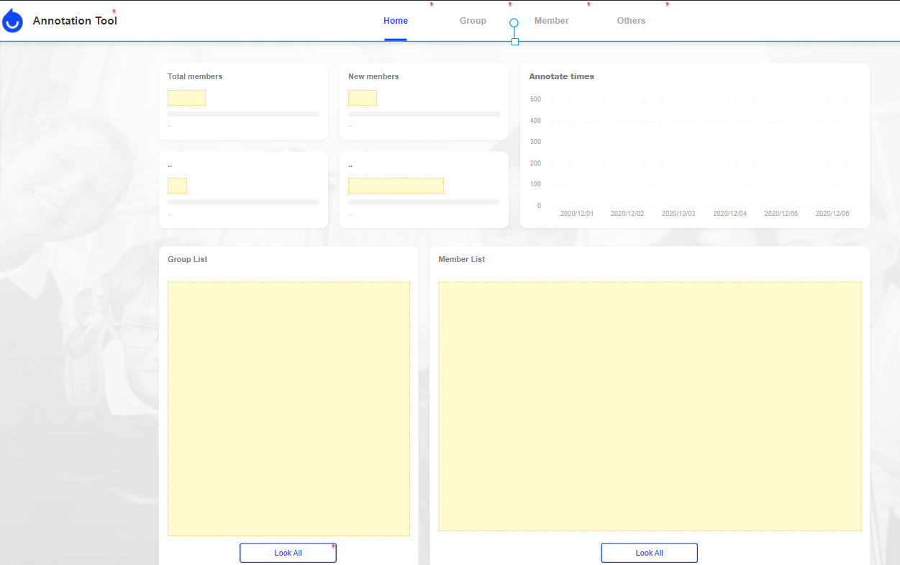

**Member list**

Display member and his role

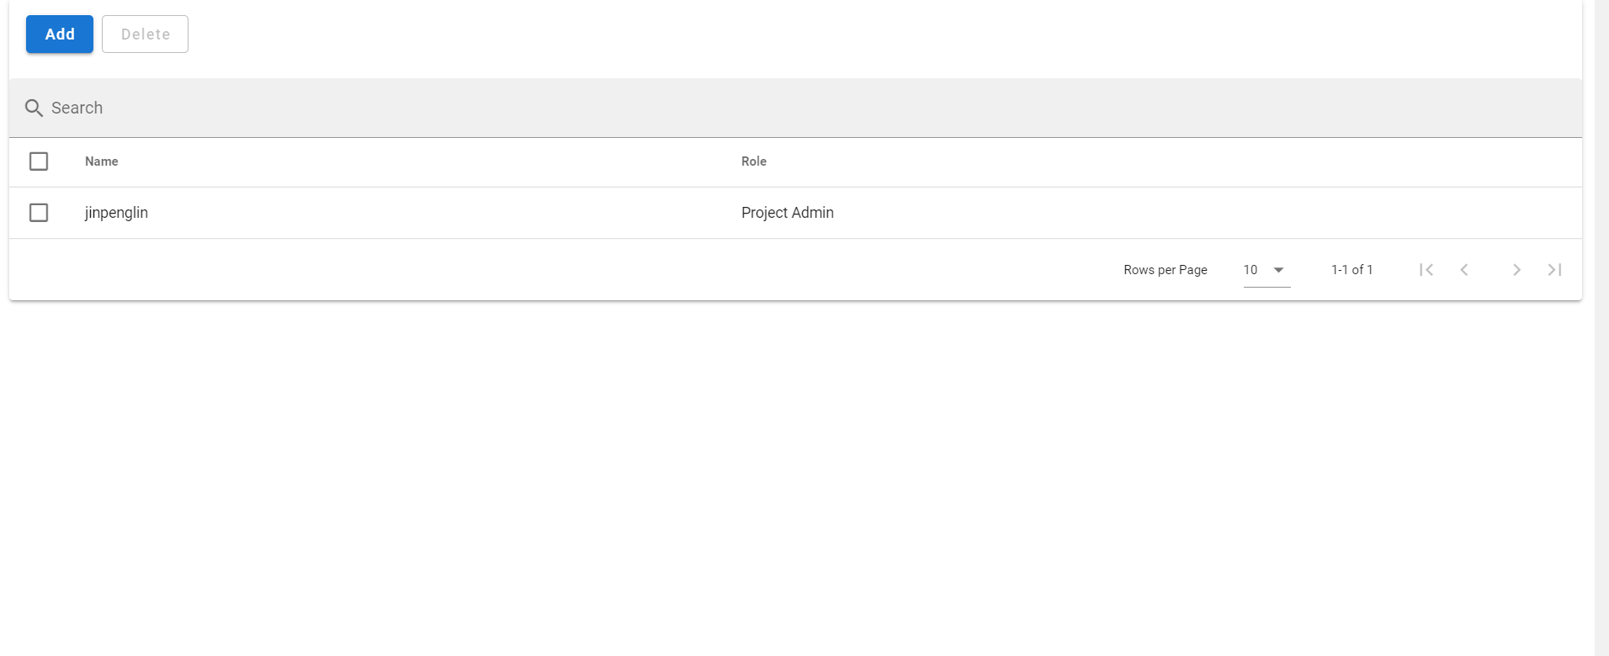

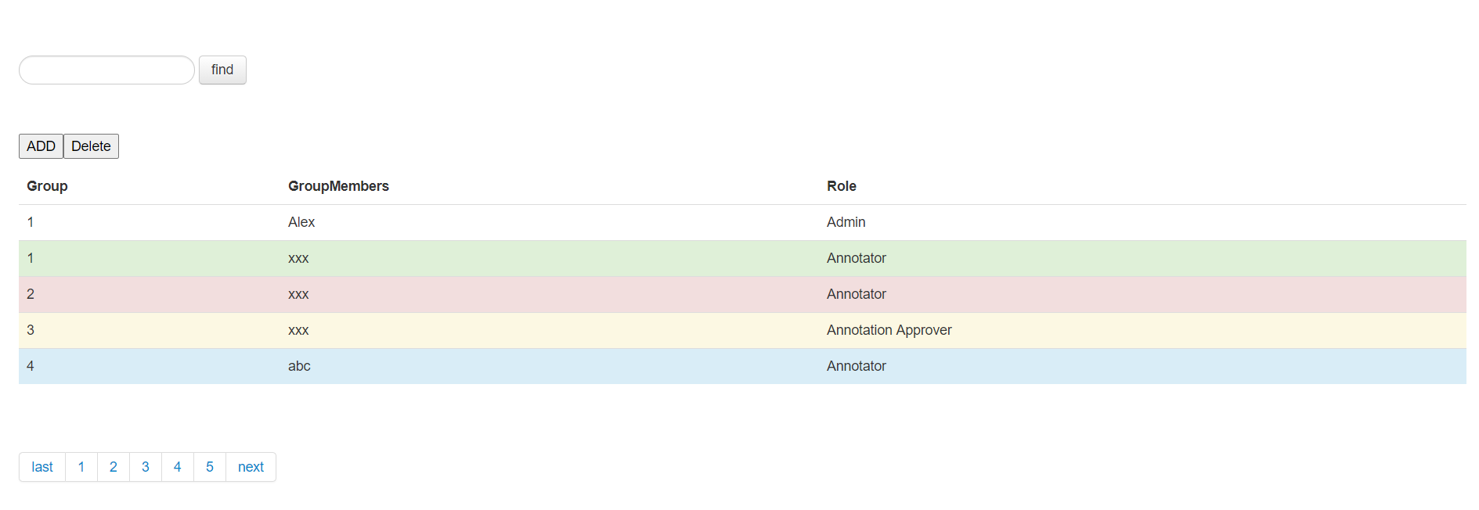

**Audit interface**

For ordinary annotators, they can only see the state of the annotation file.Including to be annotated, to be reviewed and approved.For the failed files, we directly adjust the state to be annotated, which can avoid some logical problems.For approvers, they have additional approval buttons in addition to file status.

